SHELL SCRIPTING

DATE: 19/03/2024

EXP1

echo "Enter a string:"

read userstring

echo "You entered: $userstring"

Output

snehav@sneha-v:~$ nano exp1.sh

snehav@sneha-v:~$ sh exp1.sh

Enter a string:

Shell scripting

You entered: Shell scripting



EXP2

echo "Enter the first number:"

read num1

echo "Enter the second number:"

read num2

sum=$((num1+num2))

echo "Sum: $sum"

difference=$((num1-num2))

echo "Difference: $difference"

product=$((num1*num2))

echo "Product: $product"

if [ $num2 -ne 0 ]; then

quotient=$(echo "scale=2; $num1/$num2" | bc)

echo "Quotient: $quotient"

else

echo "Cannot divide by zero. Quotient is undefined."

fi

__________________________________________

Output

snehav@sneha-v:~$ nano exp2.sh

snehav@sneha-v:~$ sh exp2.sh

Enter the first number:

44

Enter the second number:

4

Sum: 48

Difference: 40

Product: 176

Quotient: 11.00

snehav@sneha-v:~$

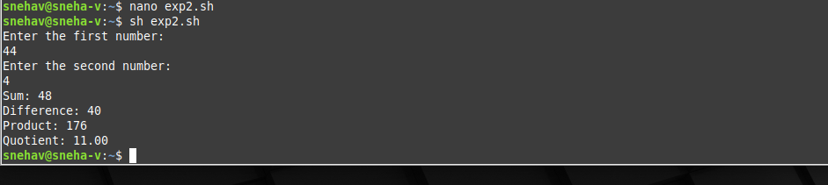

EXP3

echo "Enter a number:"

read number

if [ $((number % 2)) -eq 0 ]; then

echo "$number is even"

else

echo "$number is odd"

fi

Output

snehav@sneha-v:~$ nano exp3.sh

snehav@sneha-v:~$ sh exp3.sh

Enter a number:

15

15 is odd

snehav@sneha-v:~$

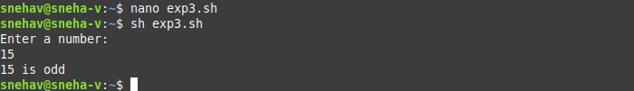

EXP4

#!/bin/bash

echo "Enter the first number:"

read num1

echo "Enter the second number:"

read num2

echo "Enter the third number:"

read num3

largest=$num1

if [ $num2 -gt $largest ]; then

largest=$num2

fi

if [ $num3 -gt $largest ]; then

largest=$num3

fi

echo "The largest number is: $largest"

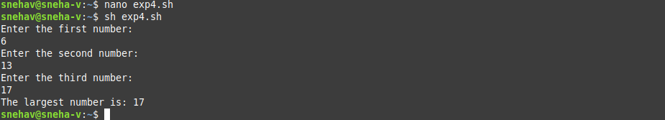

EXP5

#!/bash

echo "Enter the first mark:"

read mark1

echo "Enter the second mark:"

read mark2

echo "Enter the third mark:"

read mark3

average=$(( (mark1+mark2+mark3)/3 ))

echo "Average Mark: $average"

if [ $average -ge 90 ]; then

echo "Grade:S"

elif [ $average -ge 80 ]; then

echo "Grade:A"

elif [ $average -ge 60 ]; then

echo "Grade:B"

elif [ $average -ge 40 ]; then

echo "Grade:P"

else

echo "Grade:F"

fi

OUTPUT

snehav@sneha-v:~$ nano exp5.sh

snehav@sneha-v:~$ sh exp5.sh

Enter the first mark:

56

Enter the second mark:

49

Enter the third mark:

32

Average Mark: 45

Grade:P

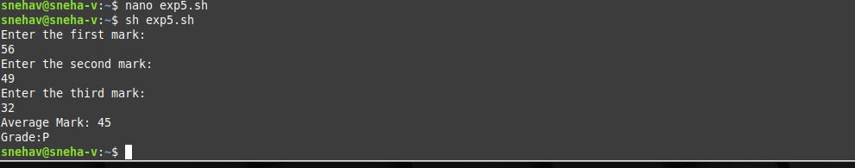

EXP6

#!/bash

if [ $# -eq 1 ]; then

echo "Please provide a filename as a command line argument"

exit 1

fi

filename=$1

if [ -e "$filename" ]; then

echo "File '$filename' exists."

else

echo "File '$filename' does not exist."

fi

OR

#!/bash

# Check if a filename is provided as a command-line argument

if [ $# -ne 1 ]; then

echo "Usage: $0 <filename>"

exit 1

fi

filename=$1

# Check if the file exists

if [ -e "$filename" ]; then

echo "File '$filename' exists."

else

echo "File '$filename' does not exist."

fi

OUTPUT

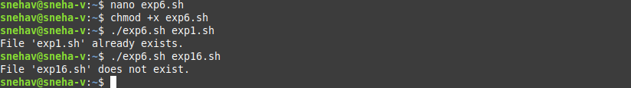

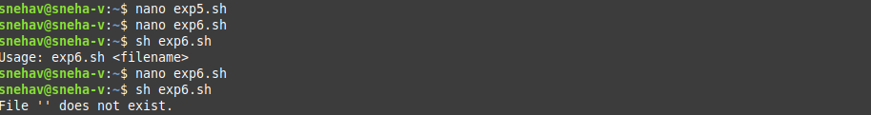

EXP7

#!/bash

echo "Enter a number:"

read n

echo "Multiplication table for $n:"

for ((i = 1; i <= 10; i++)); do

echo "$n x $i = $((n * i))"

done

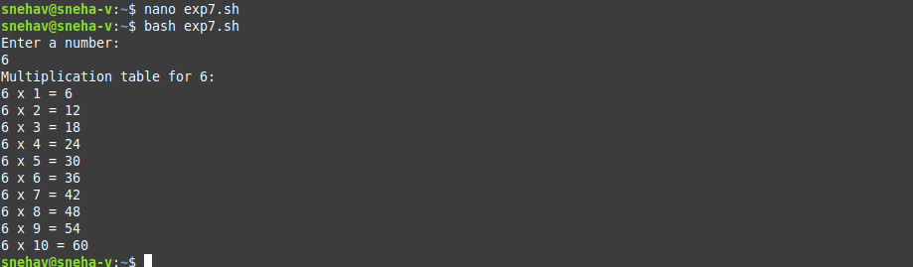

Exp8

#!/bin/bash

echo "Contents of the current folder:"

ls



EXP9

#!/bin/bash

echo "Enter the value of n:"

read n

sum=0

count=1

while [ $count -le $n ]; do

square=$((count * count))

sum=$((sum + square))

count=$((count + 1))

done

echo "The sum of squares of the first $n numbers is: $sum"

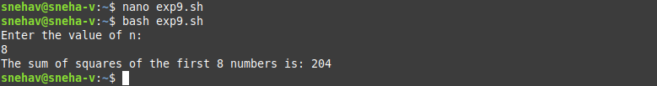

EXP10

#!/bin/bash

while true; do

echo "Menu:"

echo "1. Sum"

echo "2. Difference"

echo "3. Product"

echo "4. Quotient"

echo "5. Exit"

echo "Enter your choice: "

read choice

case $choice in

1)

echo "Enter the first number:"

read num1

echo "Enter the second number:"

read num2

sum=$((num1 + num2))

echo "Sum: $sum"

;;

2)

echo "Enter the first number:"

read num1

echo "Enter the second number:"

read num2

difference=$((num1 - num2))

echo "Difference: $difference"

;;

3)

echo "Enter the first number:"

read num1

echo "Enter the second number:"

read num2

product=$((num1 * num2))

echo "Product: $product"

;;

4)

echo "Enter the first number:"

read num1

echo "Enter the second number:"

read num2

if [ $num2 -ne 0 ]; then

quotient=$(echo "scale=2; $num1 / $num2" | bc)

echo "Quotient: $quotient"

else

echo "Error: Division by zero!"

fi

;;

5)

echo "Exiting..."

exit 0

;;

*)

echo "Invalid choice! Please enter a number between 1 and 5."

;;

esac

Done

Output

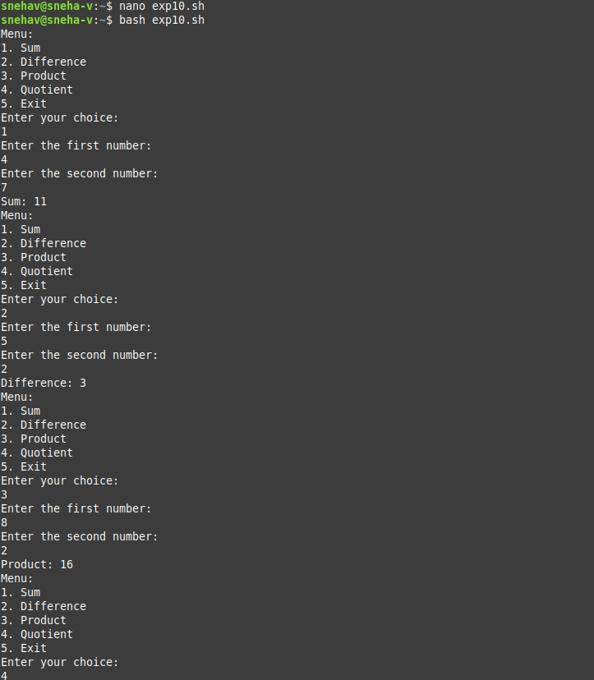

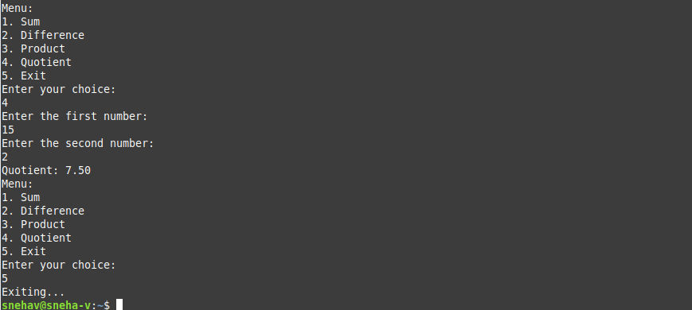

EXP11

#!/bin?bash

while true; do

echo "Menu:"

echo "1. Find month by number"

echo "2. Exit"

echo "Enter your choice: "

read choice

case $choice in

1)

echo "Enter the number of the month (1-12):"

read month_number

case $month_number in

1) echo "January";;

2) echo "February";;

3) echo "March";;

4) echo "April";;

5) echo "May";;

6) echo "June";;

7) echo "July";;

8) echo "August";;

9) echo "September";;

10) echo "October";;

11) echo "November";;

12) echo "December";;

*) echo "Invalid month number! Please enter a number between 1 and 12.";;

esac

;;

2)

echo "Exiting..."

exit 0

;;

*)

echo "Invalid choice! Please enter 1 or 2."

;;

esac

done

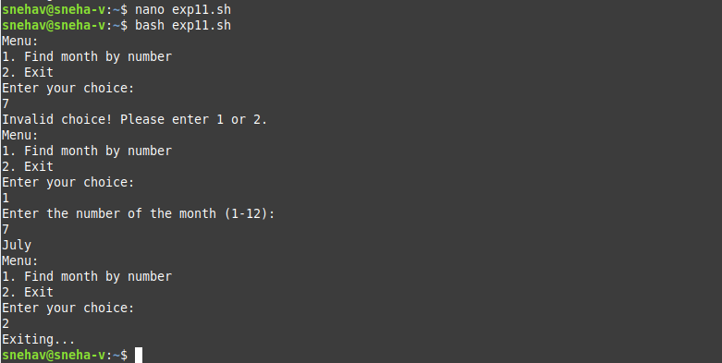

EXP12

#!/bin/bash

factorial() {

local n=$1

local result=1

if [ $n -eq 0 ]; then

echo 1

else

for ((i = 1; i <= n; i++)); do

result=$((result * i))

done

echo $result

fi

}

echo "Enter a number:"

read num

fact=$(factorial $num)

echo "Factorial of $num is: $fact"

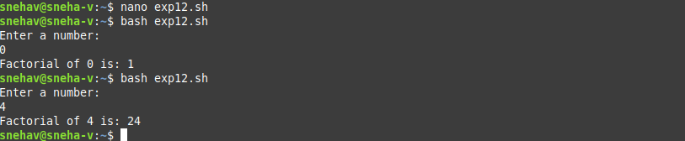

EXP13

fibonacci() {

n=$1

a=0

b=1

count=1

echo "Fibonacci sequence upto $n:"

echo -n "$a"

while [ $count -lt $n ];do

echo -n "$b"

temp=$b

b=$(( a+b ))

a=$temp

count=$(( count+1 ))

done

echo

}

echo "Enter th limit (N) for fibonacci sequence:"

read limit

fibonacci $limit

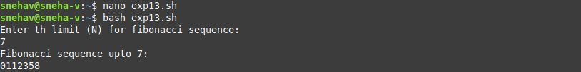

EXP14

#!/bin/bash

echo "enter a number(n):"

read n

sum=0

count=1

while [ $count -le $n ]; do

square=$(( count*count ))

sum=$(( sum+square ))

count=$(( count+1 ))

done

echo "Sum of square of the first $n number is: $sum"

8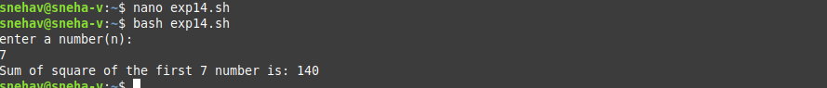

EXP15

#!/bin/bash

echo "Enter a Decimal number:"

read decimal

binary=""

remainder=0

while [ $decimal -gt 0 ]; do

remainder=$((decimal % 2))

binary="$remainder$binary"

decimal=$((decimal / 2))

done

echo "Binary equivalent: $binary"

